Base Price Checker
User Guide

Tri-E Enterprises · TOS System · Purchases &amp; Products Module
Prepared: August 26, 2026

Overview
Many products can be bought from more than one supplier, often at different prices — like the JBJ, Casini, and Fussen price list you already keep for steel products. The Base Price Checker brings that comparison into the system: record what each supplier charges for a product once, and every time you create a Purchase Order for that product, you'll see all recorded supplier prices side by side.

This is a comparison tool, not an automatic price-setter — it never changes the price you enter on a Purchase Order. It just shows you what each supplier is known to charge, so you can catch an overpriced quote before confirming it.

ℹ There are two steps: (1) record supplier base prices on the **Product**, and (2) view the comparison while creating a **Purchase Order**.

1. Recording Supplier Base Prices
Do this once per product — whenever you learn a new supplier's price, or a price changes.

- Go to Inventory & Sales → Products and open the product you want to price-check (or create a new one).
- Scroll to the Supplier Base Prices section.
- Click Add to supplier Base Prices.
- Choose a Supplier and enter their Base Price for this product.
- Repeat for every supplier you buy this product from.
- Click Save changes.

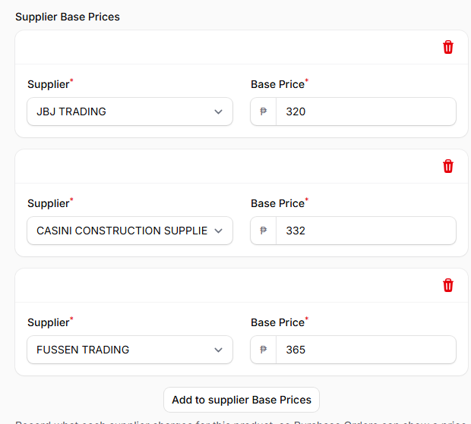
Product → Edit → Supplier Base Prices (example: Angle Bar 3mm x 1 (1/4))
ℹ You can add as many suppliers as you want, and update a price at any time — just edit the amount and save again.

2. Comparing Prices on a Purchase Order
Once a product has base prices recorded, the comparison shows up automatically while you're building a Purchase Order.

- Go to Inventory & Sales → Purchases and click Create (or open an existing purchase and click Edit).
- Choose the Supplier you're ordering from.
- In the Purchase Items section, choose the Product on the line item.
- A Base Price by Supplier list appears, showing every supplier's recorded price for that product — cheapest first.
- The supplier you chose in step 2 is shown in bold, marked "(selected supplier)", so you can immediately see if their price is the best one available.

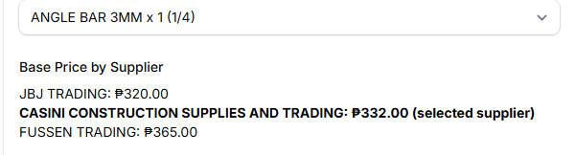
Purchase Order line item — Base Price by Supplier comparison
In this example, the Purchase Order is being placed with Casini, and the comparison shows Casini's price (₱332.00) is actually higher than JBJ's (₱320.00) for the same product — a signal worth double-checking before confirming the order.

ℹ If a product has no supplier base prices recorded yet, the panel simply says "No supplier base prices recorded yet for this product." — nothing else changes, and you can still fill in the Purchase Order as normal.

3. Good to Know
- *It's read-only.** The comparison never fills in or overrides the Price field on the Purchase Order — you still type in the actual cost yourself.
- *It's per product.** Each product keeps its own list of supplier prices; there's nothing to set up per Purchase Order beyond picking the product.
- *It updates instantly.** Changing the product or the supplier on the Purchase Order refreshes the comparison right away — no need to save first.
- *Prices can be edited anytime.** If a supplier changes their price, just update it on the Product's Supplier Base Prices section — every future Purchase Order will reflect the new number.

Tri-E Enterprises · TOS System

